CWC PCC 2021 Fall

Final Report

21Su01-CWC
Yuanhua Zhao
Yuxuan Gu

2021



Project Sponsor: David Michael Willy
Faculty Advisor: David Michael Willy
Sponsor Mentor: David Michael Willy
Instructor: David Michael Willy

DISCLAIMER
This report was prepared by students as part of a university course requirement. While considerable effort has been put into the project, it is not the work of licensed engineers and has not undergone the extensive verification that is common in the profession. The information, data, conclusions, and content of this report should not be relied on or utilized without thorough, independent testing and verification. University faculty members may have been associated with this project as advisors, sponsors, or course instructors, but as such they are not responsible for the accuracy of results or conclusions.

EXECUTIVE SUMMARY
The proposal of the project is to extend the current CWC PCC data collect system for more functionality and compatibility and to compile several detailed experimental manuals according to the functions of the new system. The request we received is to expand the capacity of the current system. We found that the original equipment can already measure voltage, current, wind speed, temperature, and pressure, so we plan to add two subsystems to collect data from solar and thermoelectric. The purpose of making this device is to support the Energy Club outreach activities, so we take into account the issue of portability, all subsystems are detachable and modular. Our design helps people’s interest in wind power augmenting and be also recyclable or converted into a small weather observation machine.
This project will extend the capabilities of the current CWC PCC data collection system for micro-wind turbines. Specifically, the project will add in a more flexible load option and higher resolution acquisition for characterizing solar cells and thermoelectric generators that would be used for Energy Club outreach activities. The current system collects voltage, current, wind speed, temperature, and pressure to characterize wind turbines.
After analyzing the CRs & ERs as well as the existing designs, we generated several concepts. In the concept of the whole system, we mainly considered how to combine the subsystems together. We have generated two concepts: integration and modularity. These two different concepts will be described and analyzed in detail below.
One of the concepts is to connect and fix all the electrical generation subsystems to the analysis & operation subsystem, that is, integration. The advantage of this concept is that it is more convenient to use, and the operator only needs to start the system without connecting the subsystems and debugging. At the same time, because all the components have been fixed, the reliability of this concept is higher. The disadvantage of this concept is that it is not easy to carry. Because this system can support three different electrical experiments, if the operator only needs to do one of them, it is very inconvenient to take out the whole system. Also, because all subsystems are integrated together, when the system fails, the workload of locating errors will be very heavy. That's one of the drawbacks of this concept as well.
Unlike another concept, modularity does not interconnect subsystems. The operator needs to connect the corresponding subsystems and debug them. So the disadvantage of this concept is that it will make the operator have more workload. The advantage of this concept is that it's portable. When doing a specific experiment, the operator only needs to carry the corresponding subsystems. At the same time, we plan to install a test interface in each subsystem to reduce the workload of debugging and maintenance.
Because our project is mainly to extend the old system rather than design a new one, and the client has very specific requirements for our concept selection, the methods to meet CRs and ERs are very limited. For each different subsystem, we have only about two alternative concepts.
So far, we believe that these concepts can meet CRs and ERs to the greatest extent, and have great feasibility：RaspberryPi, Eventek KPS305D Adjustable Switching Regulated Power Supply, wind turbine (Box fan), solar panel (Sunlight), seebeck TEG (Ice).
The result is that the feasibility of the system is reliable. In our online simulation, the interfaces are the same and the power equipment is running well. Although the data collection system has not yet been produced, the sensors are running well and the simulation environment is mature. You can proceed to the next step. test.

ACKNOWLEDGEMENTS
Firstly, thank our advisors David Trevas and David Willy. In this stormy and troubled 2021, we have experienced many twists and turns. From the summer when the team had to work online to the fall of the flagstaff epidemic, the project faced multiple difficulties, which were all overcome one by one. With the help of library 3D printing technology, the support of the engineering lab, and many online materials, and the careful guidance of the instructor, we can complete this project. This makes us clearly understand the truth: the Great Wall is not built in a day, nor is it a person.

TABLE OF CONTENTS
Contents
DISCLAIMER 1
EXECUTIVE SUMMARY 1
ACKNOWLEDGEMENTS 2
TABLE OF CONTENTS 3
BACKGROUND 2
Introduction 2
Project Description 2
REQUIREMENTS 3
Customer Requirements (CRs) 4
Engineering Requirements (ERs) 5
Functional Decomposition 6
Black Box Model 6
Functional Model/Work-Process Diagram/Hierarchical Task Analysis 6
House of Quality (HoQ) 7
Standards, Codes, and Regulations 8
DESIGN SPACE RESEARCH 10
Literature Review 10
Benchmarking 10
System Level Benchmarking 11
9610-C-1 Orion LX Weather Station with Display Console 11
WeatherHawk 916 Wireless Weather Station 11
Capricorn FLX Weather Station 11
Subsystem Level Benchmarking 12
Solar Radiation 12
200SZ Silicon Pyranometer, 4-20mA 12
Amplified 0-5 V Full-Spectrum Quantum Sensor 12
Apogee Smart Pyranometer 13
Wind sensor 13
05501LM Intrinsically Safe Wind Monitor-IS 13
102874 Sonic Wind Sensor 13
WS-23 Current Loop Wind Sensor 13
Thermoelectric generating device 14
CN103532439B[10] 14
SP1848-27145 Peltier TEG Module 14
TEG1-199-1.4-0.5 15
CONCEPT GENERATION 16
Full System Concepts 16
Integration 16
Modularity 16
Subsystem Concepts 16
Analysis and operating subsystem 16
Laptop 16
Arduino 16
RaspberryPi 17
Power subsystem 17
Rigol DL3021A Programmable DC Electronic Load 17
East Tester ET5410 single-channel Programmable Electronic Load 17
Eventek KPS305D Adjustable Switching Regulated Power Supply 17
Wind turbine system 17
Box fan 17
Ventilation Fan 17
Solar panel subsystem 17
Thermoelectric subsystem 17
Peltier Module 17
Seebeck TEG 17
Ice for generating temperature difference 18
Boiling water for generating temperature difference 18
DESIGN SELECTED – First Semester 19
Technical Selection Criteria 19
Rationale for Design Selection 19
IMPLEMENTATION – Second Semester 21
Design Changes in Second Semester 21
Design Iteration 1: Change in data collection system discussion 21
Design Iteration 2: Change in subsystem discussion 21
RISK ANALYSIS AND MITIGATION 22
Potential Failures Identified First Semester 22
Potential Failures Identified This Semester 22
Risk Mitigation 22
ER Proofs 23
ER Proof #1 – [State Engineering Requirement #1 here] 23
ER Proof #2 – [State Engineering Requirement #2 here] 23
LOOKING FORWARD 24
Future Testing Procedures 24
Testing Procedure 1: Descriptive Title 24
Testing Procedure 1: Objective 24
Testing Procedure 1: Resources Required 24
Testing Procedure 1: Schedule 24
Testing Procedure 2: Descriptive Title 24
Testing Procedure 2: Objective 24
Testing Procedure 2: Resources Required 24
Testing Procedure 2: Schedule 24
Future Work 25
CONCLUSIONS 26
Reflection 26
Post Mortem Analysis of Capstone 26
Contributors to Project Success 26
Opportunities/areas for improvement 26
REFERENCES 27
APPENDICES 28
Appendix A: Descriptive Title 28
Appendix B: Descriptive Title 28

BACKGROUND

Introduction
The proposal of this project is to expand the existing CWC PCC data acquisition system to obtain more functions and compatibility, and to write a number of detailed experimental manuals according to the functions of the new system. The request we received was to expand the capacity of the existing system. The original equipment can already measure voltage, current, wind speed, temperature and pressure, so the team plans to add two subsystems to collect solar and thermal data. The purpose of making this device is to support the outreach activities of the Energy Club, so we took into account the issue of portability, and all subsystems are detachable and modular. Our design contributes to people's interest in enhancing wind power generation, and it can also be recycled or converted into a small weather observation machine.

Project Description
In the concept of the entire system, we mainly consider how to combine subsystems. We have produced two concepts: integration and modularity. The following is the original project description provided by the sponsor.
The project will expand the functionality of the CWC PCC data collection system currently used for micro wind turbines. Specifically, the project will add more flexible load options and higher-resolution acquisitions to characterize solar cells and thermoelectric generators that will be used in energy club outreach activities. Current systems collect voltage, current, wind speed, temperature, and pressure to characterize wind turbines. View photos of existing systems used to characterize wind turbines.
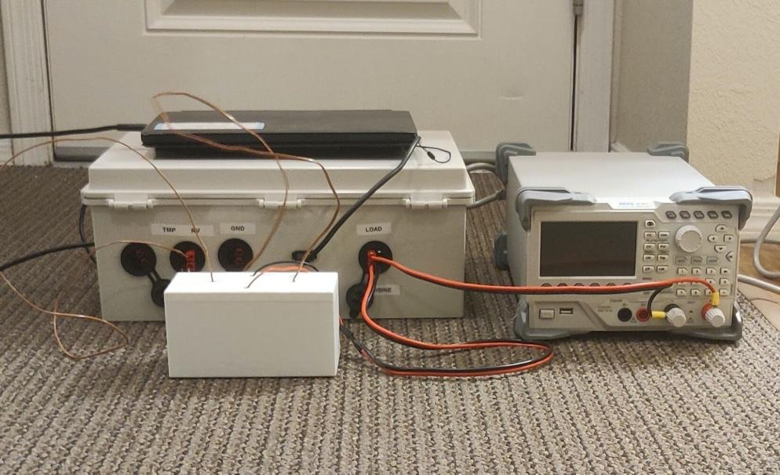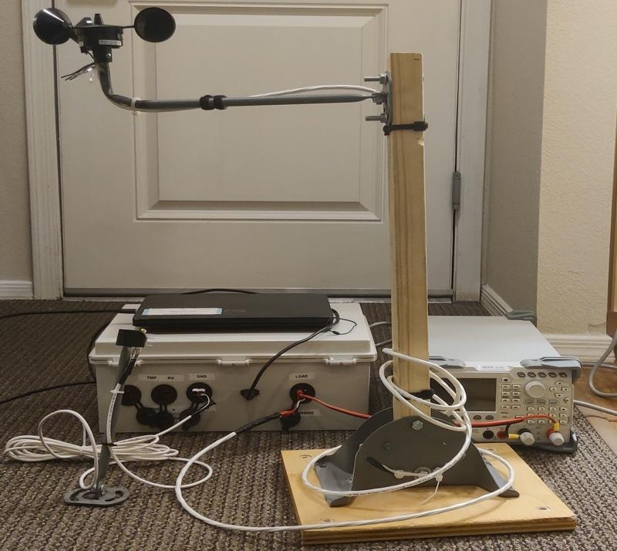
Fig 1. the current system

REQUIREMENTS
According to the requirements of the six major customers, we have formulated eight major engineering requirements. And discussed the proportion of several customer needs in the group, and the respective importance of the corresponding engineering needs. According to these requirements, the team will develop detailed test content.

Customer Requirements (CRs)
The customer requested two new sub-systems, and we derived from these two new sub-systems that solar and thermoelectric are needed. The customer is not satisfied with the current equipment, mainly because of the size problem. He did not say clearly, but proposed to replace the system with a lighter and smaller raspberry. So we sum up the following six points: easily carry, easily use, easily debug, reliability, solar, thermoelectric：
Easily carry | 4.5
Solar | 4.1
Easily use | 3.6
Thermoelectric | 4.8
Easily debug | 4.9
Reliability | 4.5
Table 1. CR
The team believes that the realization of the function is the most important requirement. Among other requirements, "easy to debug" is equally important. In this regard, the team will work hard on guidance and installation and disassembly.
First, we must implement solar energy and thermal power. This is a content requirement. Second, whether it is easy to debug depends on the nature of the data acquisition system, which is an auxiliary tool. If the tool is damaged and cannot be repaired in time, it will definitely affect the main test. Third, based on the lowest weight for ease of use, and the use of the device requires certain basic knowledge, we will explain in detail how to use it in the manual.

Engineering Requirements (ERs)
Then we investigated the elements required for a data collection system. Based on these elements, we concluded the following engineering requirements: Weight, size, simple operating system, test interface, modularization, durable, incorporate, rotational Energy, displays a phenomena of engineering.
Because this project is a graduate design of mechanical engineering, the team wants to reflect the students' professionalism and professionalism in this project, rather than looking for simpler solutions. The team optimizes the user experience and convenience as much as possible.

Weight
Size
Simple operating system
Test interface
Modularization
Durability
Price
Reliability
Table 2.ER
1. It is hoped that the total weight should be kept below 15 kg (except the load).
2. The total size of the four modules is maintained at 100x80x80cm
3. Collect the operations to the operating system. Only the security button of the module is reserved. The three functions can be turned off by the operating system. The test content of each function is clear and easy to understand and can be exported.
4. Carry out information exchange through the Ni arduino system to ensure that the interfaces of each module are clear, and it is best to mark the work.
5. To ensure absolute modularity, the connection lines are completely reserved on the subsystems except for the operating system.
6. Short-term operation for 1 hour without errors, 6 months without maintenance.
7. To be carried out within the client's budget, no more than 1,500 US dollars.

Functional Decomposition
According to the requirements of the six major customers, we have formulated eight major engineering requirements. And discussed the proportion of several customer needs in the group, and the respective importance of the corresponding engineering needs. According to these requirements, the team will develop detailed test content.

Black Box Model
This system is an information collection system, so there is no solid part. We have four inputs, wind, solar, thermoelectric, and console. The final output is a series of data.
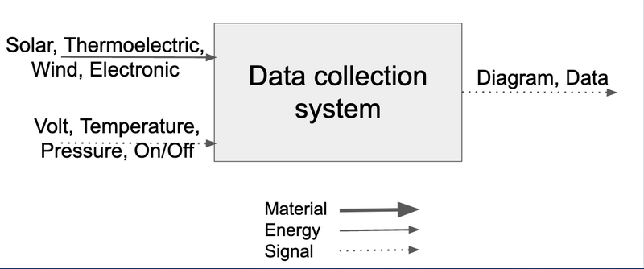
Fig 2.Black box model

Functional Model/Work-Process Diagram/Hierarchical Task Analysis
As shown in the figure, the entire functional Model is divided into three subsystems, wind, solar, and electric heat. And from how to input variables to input, to how to measure data, to how to output data. This will be divided into 4 sub-systems to collect data from three different energy sources while achieving modularity.
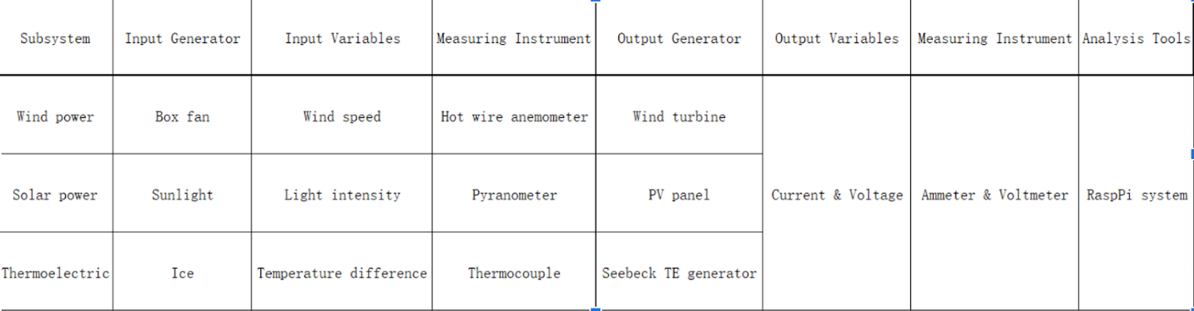
Fig 3. Functional model

House of Quality (HoQ)
When making HoQ, the team fully considered the opinions of all members and determined the proportions of all aspects. This HoQ cannot be described in terms of units, specifications and other requirements. Instead, it fully considers the relevance of various project requirements and customer requirements to provide a weight reference for the subsequent conceptual design. We generally believe that easy handling and easy debugging are the most important, which is the result of careful consideration based on customer needs. As we stated in the engineering requirements, the following requirements will be met:
It is hoped that the total weight should be kept below 10 kg. The total size of the four modules is maintained at 100x60x80cm. Collect the operations to the operating system. Only the security button of the module is reserved. The three functions can be turned off by the operating system. The test content of each function is clear and easy to understand and can be exported. Carry out information exchange through the Raspberry Pi system to ensure that the interfaces of each module are clear, and it is best to mark the work. To ensure absolute modularity, the connection lines are completely reserved on the subsystems except for the operating system. Short-term operation for 1 hour without errors, 6 months without maintenance. To be carried out within the client's budget, no more than 1,500 US dollars. Ensure that the equipment will not be damaged by the outside due to handling.
In many tests, the team listed weight, prize and size as the first item. After all the components were purchased, it would take one day to collect data and design plans for the installation and placement of subsequent tests. Then we will test the modularization and test interface, which is expected to take three days. In the third step, we will design the operating system, which will take us nearly a month, and the test simulation of this content will be completed within half a month. Finally, the team will test and adjust the Durability and Reliability of the equipment, which is expected to be half a month.
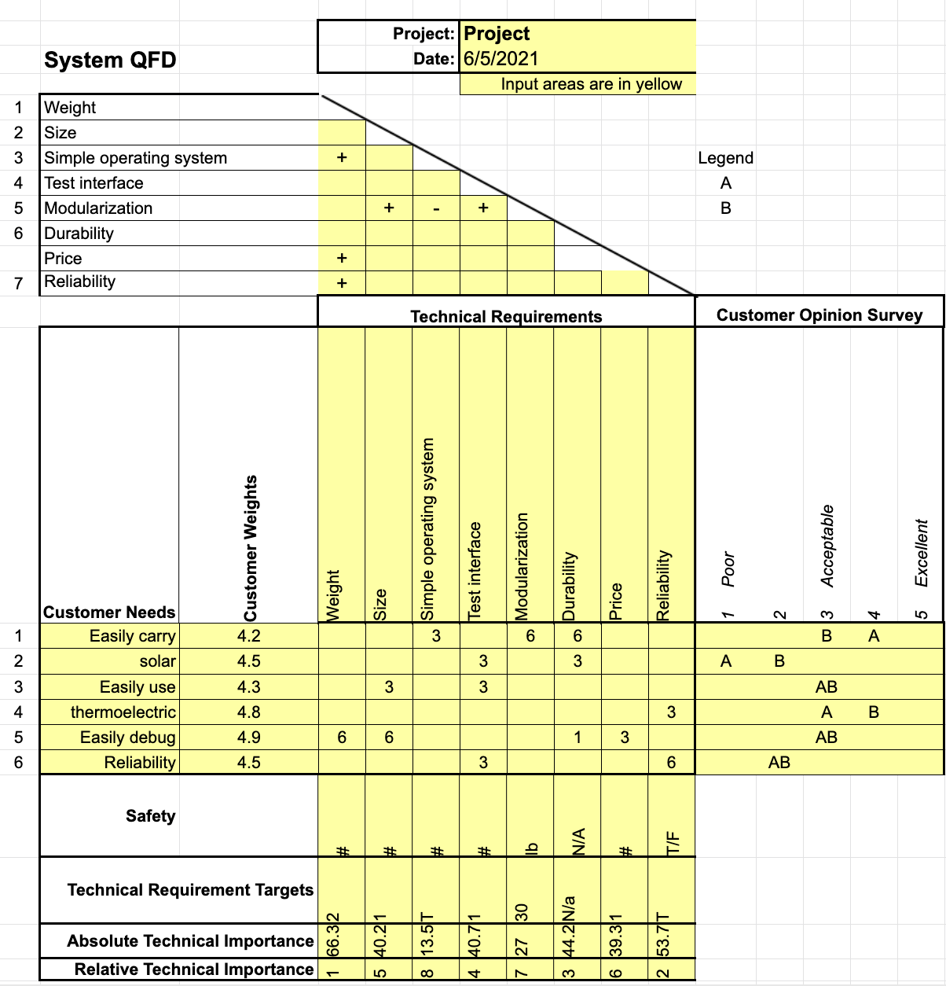
Figure 4. HoQ

Standards, Codes, and Regulations
The standards involved in this equipment are mainly various electrical safety standards. These standards will help the team play a warning role when implementing modularization and make the equipment more in line with people's usage habits.

Table 3: Standards of Practice as Applied to this Project
Standard Number or Code | Title of Standard | How it applies to Project
IEEE-1889 | Evaluating and Testing the Electrical Performance of Energy Saving Devices | Help test the safety of equipment.
ASTM | dimensioning and tolerancing standards for the drawings | Helps the team's size simulation.

DESIGN SPACE RESEARCH
This part includes our literature review and evaluation and explanation of various products on the market. The team will design our products based on this standard.

Literature Review
The efficiency of wind power generation is closely related to wind speed, rotor diameter, air density and maximum power coefficient. When making the data collection system, the team should fully consider the above-mentioned influencing factors such as the wind environment in the flagpole area and the maximum power coefficient of the equipment to prevent data overflow. In follow-up production, we strive to meet safety requirements, engineering requirements and customer needs. And it is designed for the best of the three subsystems of wind energy, solar energy and thermal energy.
When the moving air-the wind-is blocked by the surface-the kinetic energy in the wind is converted into pressure. The pressure acting on the surface is converted into force. The utilization rate of different wind turbines is different, and the utilization rate of a large horizontal axis 3-blade wind turbine varies according to the size of the wind. This means that even a small increase in wind speed will result in a substantial increase in power. This is why taller towers can increase the productivity of any wind turbine by obtaining higher wind speeds. In the six TSR conditions, the power output increases and then decreases as the blade speed (or TSRs) increases. The wake velocity deficit and the enhanced turbulence intensity also show a similar trend of first increasing and then decreasing. The largest is found The power factor appears on the turbine operating under C4 conditions (TSR = 4.1). In this case, the turbine produces the largest power output and torque, as well as the strongest wake, the largest speed deficit, turbulence intensity level, and momentum flux.
A thermoelectric generator (TEG), also known as a Seebeck generator, is a solid-state device that directly converts heat flux (temperature difference) into electrical energy through a phenomenon called the Seebeck effect (a form of thermoelectric effect). So when we estimate the efficiency of Seebeck TEG, we can simply divide the output power by the power to maintain the temperature difference. When calculating the power required to maintain the temperature difference, one of the important parameters is the heat transfer efficiency. By looking for the thermal conductivity of different materials, we found that the common material white pine can meet the demand. In the calculation, we assume that a white pine board with an area of ​​60 square centimeters and a thickness of 1 cm is used as the insulating material. The output efficiency of the thermoelectric generator is 4.46%, which is very close to the efficiency of a typical thermoelectric generator. Through the research on the working efficiency of thermoelectric generators, we have come to the conclusion that the smaller the size and the larger the thickness of the insulating material, the better the efficiency of TEG output, without affecting the installation of TEG.

Benchmarking
We investigated three different weather stations, and then we investigated solar radiation, wind measurement equipment, and thermoelectric generating devices. After investigating the above ready-made designs, we have adopted a modular design based on existing equipment and adopted various sub-systems suitable for miniaturization.

System Level Benchmarking
We generally believe that the system is closer to the weather station except for the addition of the thermal energy measurement part, so we searched the weather station on the market as a reference for the main system.

9610-C-1 Orion LX Weather Station with Display Console
We investigated the 9610-C-1 Orion LX Weather Station with Display Console, fully understood the current commercial weather station data, and gained some experience from it.
In its wind measuring instrument, both wind speed and direction are measured using an advanced ultrasonic sensor. The sensor uses ultrasound to determine horizontal wind speed and direction. The array of three equally spaced ultrasonic transducers on a horizontal plane is an ideal design which ensures accurate wind measurement from all wind directions, without blind angles or corrupted readings. The wind sensor has no moving parts, which makes the Orion LX Weather Station maintenance free. The measurement range for wind speed is from 0 to 134 mph (0 to 60 m/s) and for wind direction from 0 to 360°. [1]

WeatherHawk 916 Wireless Weather Station
The advantages of this device are:
1. Remove the WeatherHawk from the shipping box (no assembly required).
2.Install the WeatherHawk and solar panel on the user-supplied pole.
3.Attach the RF400 Spread Spectrum Radio to a serial port on the user supplied Host PC.
4.Install Virtual Weather Software and turn on the WeatherHawk weather station switch. Within minutes, a typical user can begin monitoring weather information directly on the Host PC, and remotely over the Internet. [2]

Capricorn FLX Weather Station
We value the modularization of the equipment most, and it has the following advantages: Modular design for sensor selection and optimal sensor location
1.Temperature and/or humidity in self-aspirating radiation shield
2.Many other meteorological sensor options
3.Two additional general-purpose analog channels.
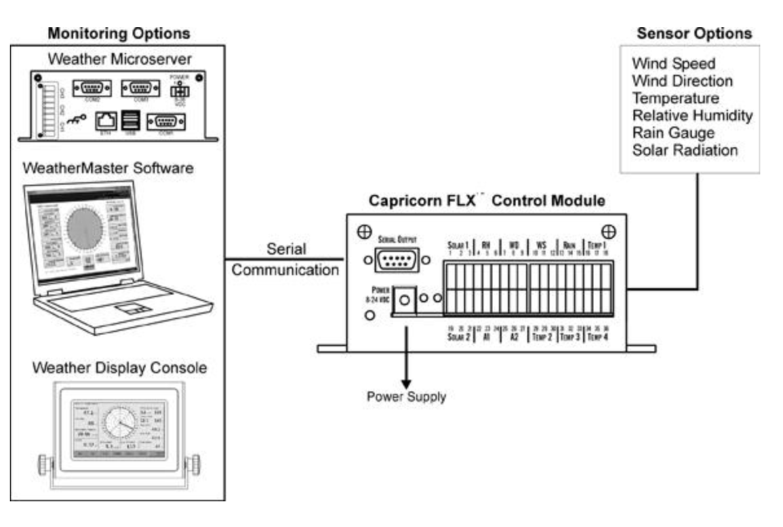
Fig 5. Capricorn FLX Weather Station

Subsystem Level Benchmarking

Solar Radiation
Solar radiation is divided into full spectrum and non-full spectrum. The most common one on the market is non-full spectrum, which is only suitable for use under sunlight. Although the full spectrum is comprehensive, it does not meet our engineering requirements.

200SZ Silicon Pyranometer, 4-20mA
The 200SZ Silicon Pyranometer is designed for solar radiation measurement in agricultural, meteorological, and solar energy studies. In clear unobstructed daylight conditions, the 200SZ Silicon Pyranometer compares favorably with first class thermopile type pyranometers, but at a fraction of the cost. It features a silicon photovoltaic detector mounted in a fully cosine-corrected miniature head. Current output, which is directly proportional to solar radiation, is calibrated under natural daylight conditions in units of watts per square meter (Wm²). Under most conditions of natural daylight, the solar radiation measurement error is less than 5%. Because the spectral response of the 200SZ Silicon Pyranometer does not include the entire solar spectrum, it must be used only in the natural daylight conditions for which it was calibrated. It should not be used under vegetation, artificial lights, in a greenhouse, or to measure reflected solar radiation. [4]

Amplified 0-5 V Full-Spectrum Quantum Sensor
The SQ-515 is an amplified full-spectrum quantum sensor with a 0 to 5 V output. The sensor incorporates a blue-enhanced silicon photodiode and custom optical filters with a rugged, self-cleaning sensor housing design, anodized aluminum body with acrylic diffuser. Typical applications include PPFD measurement over plant canopies in outdoor environments, greenhouses, and growth chambers, and reflected or under-canopy (transmitted) PPFD measurements in the same environments. Quantum sensors are also used to measure PAR/PPFD in aquatic environments, including saltwater aquariums where corals are grown.[5]

Apogee Smart Pyranometer
The new SP-420 smart pyranometer can be connected directly to a computer for taking spot measurements or graphing and data logging real-time shortwave radiation using the included software. The sensor can also act as a stand-alone shortwave radiation data logger by simply connecting it to most standard 5 V DC USB power sources. Internal memory within the sensor head is capable of storing 10,000 user-specified periodic measurements that can be downloaded as a CSV file to a computer for analysis.[6]

Wind sensor
Wind sensors have a variety of different designs, such as the latest ultrasonic measuring instrument, and the more popular runner type. The design of these devices has brought us a lot of help in subsequent production.

05501LM Intrinsically Safe Wind Monitor-IS
The Wind Monitor-IS can safely be used in Class 1, Division 1, Group A,B,C,D hazardous areas.* The wind speed sensor is a four blade propeller. The propeller drives a reliable, non-contacting transducer. The wind direction sensor is a durable molded vane. Vane angle is sensed by a precision, long-life potentiometer housed in a sealed chamber. Internal circuitry converts signals for wind speed and wind direction into separate, 4 to 20 mA current outputs. The instrument is constructed of UV stabilized plastic with stainless steel and anodized aluminum fittings. The instrument installs on standard 1 inch pipe.

102874 Sonic Wind Sensor
This high accuracy and fine resolution sonic wind sensor offer the user many years of reliable, maintenance free operation. Developed from experience gained through 35 years of research and design of micrometeorological wind instrumentation, the Model 102784 Sonic Wind Sensor is the future of wind measurement instrumentation. This sensor and sonic anemometer truly sets the standard for wind measurements and each sensor is supplied with a 16-point, NIST-traceable test certificate from our wind tunnel facility.

WS-23 Current Loop Wind Sensor
The Model WS-23 Current Loop Wind Sensor monitors wind speed and direction. The electronics convert the raw signals from the wind sensors to proportional 4 to 20 mA current loop values for use by process control or monitoring systems. This wind speed and direction sensor acts like a variable resistance that draws 4-20 mA when powered with 8 to 30 Vdc. No external power is required for this anemometer for sale because the encoding electronics for wind speed and for wind direction are isolated and powered from their respective 2-wire current loops.

Thermoelectric generating device
There are few options for thermoelectric generating devices, the more common ones are peltier and seebeck, and other integrated thermoelectric generating devices based on principles.

CN103532439B[10]
This is a dual-type thermoelectric generator, which can automatically switch between two sets of dual-type power generation devices according to changes in ambient temperature, ensuring that the device is in the power generation state at all times, and can be used for various low-power electrical equipment powered by. The device is composed of two parts: an electric energy generating device and a system control board; the electric energy generating device realizes temperature detection, thermal energy collection and thermoelectric energy conversion; the system control board realizes control of the electric energy generating device, and the system control board includes system control Electricity generators, switching devices, voltage stabilizing components, energy storage components; electrical energy generation devices include heat conducting medium, heat collecting components, thermoelectric power generation sheets, fixed support components, heat dissipation components, temperature sensor 1, temperature sensor 2.
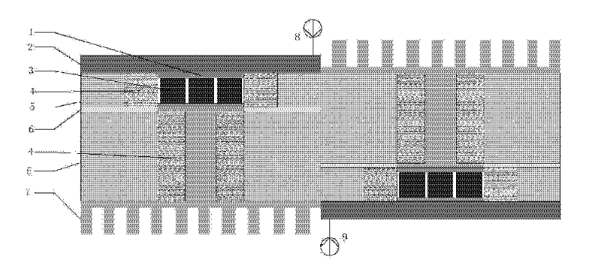
Fig 6. CN103532439B

SP1848-27145 Peltier TEG Module
These magical cells based on the Peltier effect are capable of generating electric power. The SP1848-27145 40x40mm Thermoelectric Power Generator TEG 150C Peltier Module operates maximum up to150C which will give you different voltage and current outputs at different values of temperature. Thermoelectric Power Generators also known as TEG or Peltier Modules create a detected temperature differential on each side. You can take the advantage of this temperature differential detection to generate electricity. After applying the heat on one side and cold on the other side the device will start generating voltage which depends upon the value of applied heat. TheSP1848-27145 40x40mm Thermoelectric Power Generator TEG 150C Peltier Module will generate a moderate amount of voltage with mA of current.

TEG1-199-1.4-0.5
Thermoelectric power generation sheet uses standard naming standard TEG for the thermoelectric power generation sheet is the only correct identification.1 said the power device layer. 199 for the thermoelectric power generation sheet the total PN junction log. The particle size of 1.4*1.4mm 1.4 cross-sectional area P N junction individual. 0.5 for the P node height 0.5mm N of an individual particle.

CONCEPT GENERATION

Full System Concepts
In the concept of the whole system, we mainly considered how to combine the subsystems together. We have generated two concepts: integration and modularity. These two different concepts will be described and analyzed in detail below.

Integration
One of the concepts is to connect and fix all the electrical generation subsystems to the analysis & operation subsystem, that is, integration. The advantage of this concept is that it is more convenient to use, and the operator only needs to start the system without connecting the subsystems and debugging. At the same time, because all the components have been fixed, the reliability of this concept is higher. The disadvantage of this concept is that it is not easy to carry. Because this system can support three different electrical experiments, if the operator only needs to do one of them, it is very inconvenient to take out the whole system. Also, because all subsystems are integrated together, when the system fails, the workload of locating errors will be very heavy. That's one of the drawbacks of this concept as well.

Modularity
Unlike another concept, modularity does not interconnect subsystems. The operator needs to connect the corresponding subsystems and debug them. So the disadvantage of this concept is that it will make the operator have more workload. The advantage of this concept is that it's portable. When doing a specific experiment, the operator only needs to carry the corresponding subsystems. At the same time, we plan to install a test interface in each subsystem to reduce the workload of debugging and maintenance.

Subsystem Concepts
Because our project is mainly to extend the old system rather than design a new one, and the client have very specific requirements for our concept selection, the methods to meet CRs and ERs are very limited. For each different subsystem, we have only about two alternative concepts.

Analysis and operating subsystem
The main function of this subsystem is to control other subsystems and receive data from sensors in other subsystems then output graphs or tables.

Laptop
The original analysis and operation subsystem uses a laptop. The advantage of this concept is that the laptop is very easy to operate. The disadvantage is that the associated sensors are more expensive. In addition, the volume and weight of the laptop are larger than the other two concepts.

Arduino
One of the two new concepts is to use the Arduino system. Its advantages are low price and minimum volume and weight. But at the same time, its reliability and compatibility are slightly worse.

RaspberryPi
Another new concept is to use the RaspPi system. Its price is slightly higher than Arduino, and its volume and weight are also slightly larger. But it has highly compatible interfaces, which can easily connect with the monitor and various sensors.

Power subsystem
The power subsystem consists of a transformer. Its function is to provide the whole system with the required voltage and current, which is very important to ensure the operation of the whole system.

Rigol DL3021A Programmable DC Electronic Load
The advantages of this type of electronic load are high power and high regulation accuracy. At the same time, the disadvantage is that it is heavy and very expensive.

East Tester ET5410 single-channel Programmable Electronic Load
This model of electronic load has moderate power, weight and price.

Eventek KPS305D Adjustable Switching Regulated Power Supply
The advantages of this model of electronic load are low price and lightweight. The disadvantage is that the adjustable range of voltage and current is small.

Wind turbine system
This subsystem is mainly composed of a wind turbine, wind generator and anemometer. We mainly need to choose a suitable wind generator.

Box fan
An ordinary van fan has many advantages: low price, large air flow and large air flow range. At the same time, its weight is within the acceptable range.

Ventilation Fan
The ventilation Fan has the advantages of light weight and low price; The disadvantages are small air flow and concentrated air flow range.

Solar panel subsystem
This subsystem includes solar panels and a pyranometer. We don't have many options for the design of this subsystem. We don't need to prepare a specific light source for the solar panel, so we only need to select the solar panel and pyranometer matching with the analysis subsystem.

Thermoelectric subsystem
The subsystem consists of a thermoelectric generator, a temperature difference generator and a thermocouple. For this subsystem, it is very important to select a suitable thermoelectric generator and temperature difference generation mode.

Peltier Module
The advantage of this concept is high output power, the disadvantage is poor heat dissipation and slightly higher price.

Seebeck TEG
The advantage of this concept is better heat dissipation and lower price, but the disadvantage is lower output power.

Ice for generating temperature difference
The advantages of this concept can help TEG heat dissipation and higher security. However, the temperature difference produced by this method is small, and it is unable to maintain a stable temperature difference.

Boiling water for generating temperature difference
The advantage of this concept is that it can produce large and relatively stable temperature differences. But the disadvantage is that it will further aggravate the heat dissipation problem of TEG, and there are some security risks.

DESIGN SELECTED – First Semester

Technical Selection Criteria
In this project, the most important demand we attach importance to is the specific requirements of the client. Because the client's requirements are highly professional, so as a reference, both CRs and ERs can be well considered. On the whole, we choose the concept based on lower price and acceptable accuracy. At the same time, we can improve the stability and availability of the whole system through some building methods.

Rationale for Design Selection
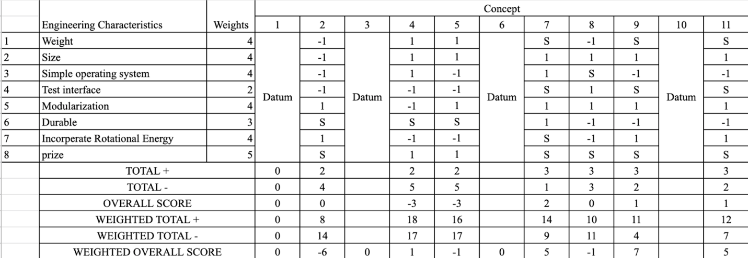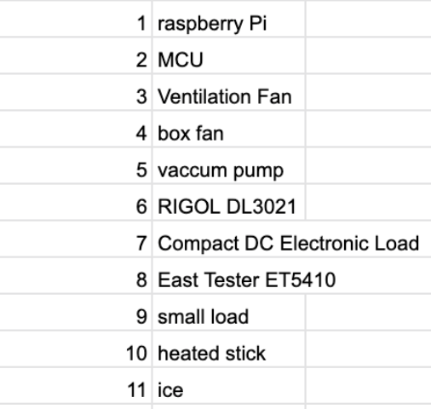
Figure 7. Pugh chart

After Pugh chart analysis and considering the client’s opinions, we have made the following choices for the concepts in the previous section:

System / Subsystem | Top concept
Full system | Modularity
Analysis and operating subsystem | Raspberry Pi
Power subsystem | Eventek KPS305D Adjustable Switching Regulated Power Supply
Wind turbine subsystem | Wind turbine (Box fan)
Solar panel subsystem | Solar panel (Sunlight)
Thermoelectric subsystem | Seebeck TEG (Ice)
Table 3. Top concept
So far, we believe that these concepts can meet CRs and ERs to the greatest extent and have great feasibility.

IMPLEMENTATION – Second Semester

Design Changes in Second Semester
There are no major changes in this project, and some changes are as follows. The programming language of the project was originally intended to use python or Java. The team previously studied the original system. It can be determined that the programming language of NI Labview used in the original system is C++. Considering compatibility and reducing workload, the team is discussing whether to continue to use Ni arduino and labview. The team originally planned to put all the subsystems into the container, but the volume of the wind turbine was too large, and because it needed to retain the original base design, it was looking for a more suitable solution.

Design Iteration 1: Change in data collection system discussion
This change stems from the testing and distrust of the Raspberry Pi. If the work we have done cannot be run on the Raspberry Pi, we will use labview to connect to NI to reassemble and write the program very quickly, because the underlying logic is the same, so there is no big problem.
The design of Raspberry Pi is not a failure, but an advance control of possible risks. I hope that the original design can succeed, and that there is still a way out in the event of unsuccessfulness. At present, the Raspberry Pi design is in trouble, and the team still uses the original system to test the hardware. This has a great possibility. The team will continue to use the original system and run the information collection system on the laptop.

Design Iteration 2: Change in subsystem discussion
The team originally planned to put all the subsystems into the container, but the volume of the wind turbine was too large, and because it needed to retain the original base design, it was looking for a more suitable solution. The independence of the wind energy measurement system is inevitable because of its huge volume and independent usage. As a subsystem, it cannot be stored and folded normally, and takes up a large space. This problem cannot be solved, and transportation is a problem, so we consider placing it regardless , Fusion of the other two subsystems. The thermal energy system and the light energy system are likely to be placed together, so the volume and functional arrangement are reasonable.

RISK ANALYSIS AND MITIGATION

Potential Failures Identified First Semester
We lack the corresponding knowledge background, so there is a big deviation in the preliminary design of the project. In our initial expectation, the CWC-PCC project is to collect and analyze relevant data. The various generators in the system simply generate voltage and current data. But in the design process, we realized that the working environment of the generator would bring many problems. For example, in the initial design of the TEG subsystem, we focused on maintaining a stable temperature difference, because this is conducive to outputting relatively stable data for analysis. But at the time we didn't know that TEG had serious heat dissipation problems. Our preliminary design will seriously affect the service life of TEG. After being aware of the problem, we redesigned the TEG subsystem and adopted a different temperature difference generation method to create a more reasonable working environment for TEG. This complete redesign undoubtedly increased the workload. Fortunately, there is no interference between the subsystems, which also allows us to work smoothly.

Potential Failures Identified This Semester
There are potentially a lot of practical installation problems this semester. First of all, we encountered the problem of insufficient tools. When installing different accessories, we found that the necessary parts lacked the tools required for installation. For example, we lacked tools that can compress the round connectors when connecting wires and connectors. Then we lack the necessary interfaces, such as the U interface for electric load, which is a very common interface. We presuppose that the merchant will bring this kind of wire, but it does not. And we reprinted the 3D parts twice, once because of the mistake of the orderer, and the other time because the CAD drawing was not saved after the tolerance was modified, which caused the plug-in to be unable to insert the reserved groove. And we found that even if the wind sensor is installed according to the instructions of the original device, the device is still in an unusable state. We suspect that the previous group of units failed to compile the wind sensor correctly. We originally planned not to change the wind power subsystem, so we did not reserve it. Time was given to the wind sensor, which caused the part of the device to be completely untestable. The light meter sponsored by the customer did not meet our expectations. It has a lot of problems. We have spent a lot of time dealing with these problems.

Risk Mitigation
Some of these issues have been resolved, and some remain unresolved. We solved most of the hardware problems. Re-purchase the wind sensor to replace the original broken parts, re-soldering the damaged illuminator, and 3D printed parts that cannot be used due to machine errors, either use an electric soldering iron to correct them or reprint them.

ER Proofs
[Use this section to discuss the Engineering Requirement proofs developed by the team. ER Proofs MUST be detailed enough to completely describe how each Engineering Requirement was proven to be satisfied (including what program or equations were used, how the test was completed (calculated), etc.). Each team must include proofs that verify the system is reliable and robust (i.e. can withstand numerous tests, withstand external forces such as drops or impacts, etc.).]
[Include a brief introduction to this section here before moving on.]
[Each Engineering Requirement must have its own subsection as shown to clearly describe how your team met the ERs.]

ER Proof #1 – [State Engineering Requirement #1 here]
[Describe how your team proved that this ER has been satisfied in your design. Clearly outline the program, software, and/or equations that was be used to prove the ERs have been met.]

ER Proof #2 – [State Engineering Requirement #2 here]

[Insert enough subsection headers and content into this section to clearly outline every Engineering requirement.]

LOOKING FORWARD
Based on the current completion of the project, the work to be continued in the future includes two parts: testing and improvement. The main content of the test is the accuracy of the experimental data obtained by each subsystem. The main content of the improvement is to use Raspberry Pi to replace the current laptop as the operating system.

Future Testing Procedures
The test process will include four parts: the test of three subsystems and the test of output voltage and current.

Testing Procedure 1: Wind Turbine

Testing Procedure 1: Objective
The purpose of this part of test is to obtain the relationship between wind speed and output voltage of the wind turbine.

Testing Procedure 1: Resources Required
The hardwares required for this test includes: PCC operating and analysis subsystem, wind turbine subsystem and box fan (not required if the test is conducted outdoors)
The softwares required for this test includes: NI LabVIEW and excel (installed in the operating and analysis subsystem)

Testing Procedure 1: Schedule
The operation process of this test is as follows
- connect the wind turbine subsystem to the operating and analysis subsystem,
- start the corresponding NI LabVIEW file,
- use the box fan or natural wind as the wind source,
- run the program to obtain the data of wind speed and output voltage
- use Excel to process and analyze the data.

When using the box fan as the wind source, the wind speed can be changed by changing the distance between the fan and the wind turbine.

Testing Procedure 2: Solar Panel

Testing Procedure 2: Objective

The purpose of this part of test is to obtain the relationship between light intensity and output voltage of the solar panels

Testing Procedure 2: Resources Required
The hardwares required for this test includes: PCC operating and analysis subsystem, solar power subsystem
The softwares required for this test includes: NI LabVIEW and excel (installed in the operating and analysis subsystem)

Testing Procedure 2: Schedule
Attention: This test needs to be done outdoors in sunny weather.
The operation process of this test is as follows
- connect the solar subsystem to the operating and analysis subsystem,
- start the corresponding NI LabVIEW file,
- run the program to obtain the data of light intensity and output voltage
- use Excel to process and analyze the data.

Testing Procedure 3: Thermoelectric Generator

Testing Procedure 3: Objective

The purpose of this part of test is to obtain the relationship between temperature difference and output voltage of the thermoelectric generator.

Testing Procedure 3: Resources Required
The hardwares required for this test includes: PCC operating and analysis subsystem, TEG subsystem and a thermometer
The softwares required for this test includes: NI LabVIEW and excel (installed in the operating and analysis subsystem)
Other resources required for this test includes: ice and boiling water

Testing Procedure 3: Schedule
The operation process of this test is as follows:
- connect the solar subsystem to the operating and analysis subsystem,
- start the corresponding NI LabVIEW file
- calibrate the two thermocouples in the TEG subsystem with ice water mixture, ambient air and boiling water
- put the ice into the side without the heat sink, close the cover and ensure that the thermocouple can measure the correct temperature
- run the program to obtain the data of light intensity and output voltage
- use Excel to process and analyze the data.

Testing Procedure 4: Output Voltage and Current

Testing Procedure 4: Objective

The purpose of this part of test is to obtain the curve of different output voltages and currents of each subsystem by a short-circuit test with a digital load.

Testing Procedure 4: Resources Required
The hardwares required for this test includes: The whole PCC system (including the load)
The softwares required for this test includes: NI LabVIEW and excel (installed in the operating and analysis subsystem)

Testing Procedure 4: Schedule
The operation process of this test is as follows:
- connect the load and the subsystem to be tested to the operating and analysis subsystem
- start the corresponding NI LabVIEW file
- get the original output voltage and current by the procedure mentioned above
- use the digital load to change the voltage from 0 to 5 volt by 0.1 volt each time, collect the output current data at different output voltage
- use Excel to process and analyze the data.

Future Work
The future improvement is to use Raspberry PI instead of the laptop as the operating system. The advantage of this improvement is that the size and weight of the operating system are reduced. Moreover, Raspberry PI has better stability in use. The disadvantage is that the required data collection procedures need to be rewritten.

CONCLUSIONS

Reflection
The function of this project is similar to the reduced power generation information detector, because it involves two kinds of clean energy, and the type of data collected is more like a weather station. Today, new energy sources are constantly being developed, thermal power is gradually eliminated, nuclear power has entered people’s vision, and nuclear fusion power generation technology is gradually maturing, and people will usher in a new round of energy trade wars. The significance of our project is to provide characterization data for small-scale self-use power generation for households and communities to determine whether the site is suitable for power generation. There are still many areas for improvement in this project. I believe that the future power grid will not only be provided by the group/state monopoly, but more self-generation will participate.

Post Mortem Analysis of Capstone

Contributors to Project Success
Our purpose is to help clients and do their best to improve the CWC PCC data collection system. The team's goal is to expand the existing CWC PCC data acquisition system to obtain more functions and compatibility, and to write a number of detailed laboratory manuals based on the functions of the new system. Based on the interference bonus of force majeure, our expectation of the final result is 80%. The current project has also achieved this goal.
In the first semester, the team completed the conceptual design of the system, filled out the purchase checklist, and learned the skills like program language and electrotechnics that will be applied to the project. The team believes that we have reached the work due in the first half of the semester. With the help of the client, we confirmed the general plan and decided on the plan of each subsystem, examined the information of various equipment, and confirmed the final purchase list.
In the second semester, we purchased the required parts, repaired the damaged parts of the original equipment, assembled the test environment and body of two new subsystems, wrote the operating program of the new subsystem, and tested the solar power subsystem. We designed the project's website and poster, and discussed how to use the project.
Our team’s Ground Rules and Coping Strategies are running well. The communication between the two-person team is direct and convenient, and has the characteristics of anytime, anywhere, but due to the geographical separation of the two by the Pacific Ocean, offline assembly has not been implemented for a long time. The team guidelines only stipulate how members should deal with possible conflicts and disagreements, and do not anticipate problems in actual operations in advance.
The advantages of this project are modularity and low cost, which is convenient for mass production after the prototype machine is successfully debugged. The original parts and principles that make up this device are extremely simple. For example, the program part can be fully integrated and installed on any raspberry. The modularity of this project gives the portability of sub-scenario testing, which does not occupy space due to other subsystems, and saves electricity. Based on the purpose of this project is to assist the wind energy club, at the beginning of the design, environmental protection elements were also considered. Clean energy is the ultimate goal of the service objects of this project. We also hope to express this vision through this project.
Google drive, QQ, IEEE standard website and other applications and resources helped the team establish the initial model. The team follows the rotation modification method, through three rounds of modification, and timely discussion with the new idea, and lists the advantages and disadvantages, and decides which solution to use through a pugh chart and other methods.

Opportunities/areas for improvement
The most important thing we need to improve is time management. The first stage design can only be accepted, not perfect. On the one hand, because the summer semester is short, our group has only two members, but more because we spend a lot of time in the communication process because of the lack of relevant professional knowledge. Due to the time difference, the communication efficiency of team members is far from reaching the expected level. Under normal circumstances, we need to spend several times the time to integrate our respective ideas into a possible solution. In the second stage, the equipment frequently fails, and the required parts are rarely in place. This is also a major test for our time management. We often stagnate due to the lack of components, resulting in some of the tests that have not yet been completed, and the problem of the wind sensor has not been resolved.
In addition, we lack the corresponding knowledge background, so there is a big deviation in the final design of the project. In our initial expectation, the CWC-PCC project is to collect and analyze relevant data. The various generators in the system simply generate voltage and current data. But in the design process, we realized that the working environment of the generator would bring many problems. For example, when testing a solar panel, there is a huge difference between indoor light and sunlight. If indoor light is used, it cannot give data normally. And for the sake of TEG life, the power generation method of hot water and ice is used, because the temperature difference is not too large, and the TEG heat dissipation causes the dissolution of the ice, and the sealing of the equipment needs to be strengthened, which will cause the liquid on both sides to convection slightly. The software part also has a lot of room for improvement. We originally planned to put the new subsystem in the same file, but we could not realize it due to limited capabilities.

REFERENCES
[1]“Orion LX Weather Station: Industrial Weather Stations,” Scientific Sales, Inc. [Online]. Available: https://www.scientificsales.com/Orion-LX-Weather-Station-with-Display-Console-p/9610-c-1.htm. [Accessed: 18-Jul-2021].
[2]“WeatherHawk 916: Wireless Weather Stations: Scientific Sales,” Scientific Sales, Inc. [Online]. Available: https://www.scientificsales.com/WeatherHawk-916-Wireless-Weather-Station-p/weatherhawk%20916.htm. [Accessed: 18-Jul-2021].
[3]“Capricorn FLX Weather Station: Weather Monitoring System,” Scientific Sales, Inc. [Online]. Available: https://www.scientificsales.com/8158-A-1-Capricorn-FLX-Weather-Station-p/8158-a-1.htm. [Accessed: 18-Jul-2021].
[4]“Silicon Pyranometer: Solar Radiation Measurement: Scientific Sales,” Scientific Sales, Inc. [Online]. Available: https://www.scientificsales.com/200SZ-Silicon-Pyranometer-p/200sz.htm. [Accessed: 18-Jul-2021].
[5]“SQ-515 Amplified 0-5 V Full-Spectrum Quantum Sensor,” Scientific Sales, Inc. [Online]. Available: https://www.scientificsales.com/SQ-515-Amplified-0-5V-Full-Spectrum-Quantum-Sensor-p/sq-515.htm. [Accessed: 18-Jul-2021].
[6]“SP-420 Apogee Smart Pyranometer,” Scientific Sales, Inc. [Online]. Available: https://www.scientificsales.com/SP-420-Apogee-Smart-Pyranometer-p/sp-420.htm. [Accessed: 18-Jul-2021].
[7]“05501LM Intrinsically Safe Wind Monitor-IS,” Scientific Sales, Inc. [Online]. Available: https://www.scientificsales.com/05501LM-Intrinsically-Safe-Wind-Monitor-IS-p/05501lm.htm. [Accessed: 18-Jul-2021].
[8]“Sonic Wind Sensor: Anemometers for Sale: Sonic Anemometer,” Scientific Sales, Inc. [Online]. Available: https://www.scientificsales.com/102874-Sonic-Wind-Sensor-p/102874.htm. [Accessed: 18-Jul-2021].
[9]“Wind Speed and Direction Sensor: Anemometer for Sale,” Scientific Sales, Inc. [Online]. Available: https://www.scientificsales.com/WS-23-Current-Loop-Wind-Sensor-p/ws-23.htm. [Accessed: 18-Jul-2021].
[10]fang deng, “一种对偶型温差发电装置,” 19-Sep-2015.

APPENDICES
[Use Appendices to include lengthy technical details or other content that would otherwise break up the text of the main body of the report. These can contain engineering calculations, engineering drawings, bills of materials, current system analyses, and surveys or questionnaires. Letter the Appendices and provide descriptive titles. For example: Appendix A-House of Quality, Appendix B- Budget Analysis, etc. All Appendices should start on a new page.]

Appendix A: Descriptive Title

Appendix B: Descriptive Title

